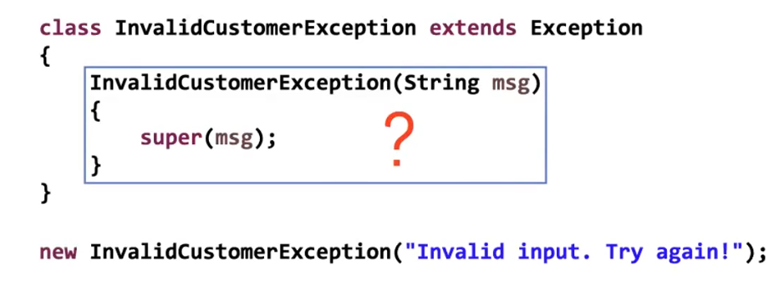

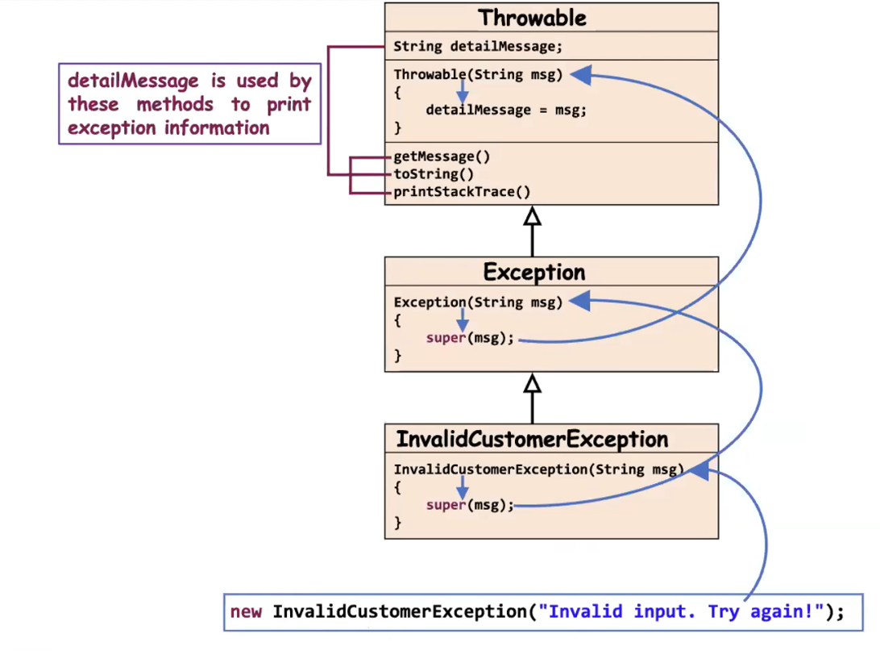

Eg: Exceptional_Handling_Eg9
🔥 What Actually Happens Internally
Step 1
Class is loaded by JVM.
Step 2
Static variables are initialized first.
static int[] a;
Since not initialized:
a = null;

Step 3
Static block runs automatically.
a[0] = 2;
But a is null.
So JVM throws:
NullPointerException

Step 4
Since exception happens inside static block:
JVM wraps it inside:
ExceptionInInitializerError

🔥 Final Output
You will see something like:
Exception in thread "main" java.lang.ExceptionInInitializerError
Caused by: java.lang.NullPointerException

🎯 Very Important Concept
When an exception occurs inside:
- Static block
- Static variable initialization
JVM throws:
ExceptionInInitializerError
Not just NullPointerException.

🧠 Why main() Does Not Execute?
Because:
- Class initialization fails
- Class loading stops
- main() never runs

✅ How to Fix It
Initialize array properly:
static int[] a = new int[5];
Now no exception.

Eg: Exceptional_Handling_Eg10
// go through the code

Eg: Exceptional_Handling_Eg11
// go through the code

When overriding a method, the child method:
- Can throw the same checked exception
- Can throw a subclass of that checked exception
- Can throw no exception
- Cannot throw a broader (parent) checked exception
And yes — even if you use the throw keyword inside the method body, you still cannot throw a broader checked exception than what the parent method allows.
The restriction comes from the method signature (throws clause) and overriding rules, not from the throw keyword itself.

Example (Valid)
Parent:
public void m1() throws IOException
Child (valid):
public void m1() throws IOException {
throw new FileNotFoundException(); // subclass of IOException
}

Example (Invalid)
Parent:
public void m1() throws IOException
Child (invalid):
public void m1() throws IOException {
throw new Exception(); // broader than IOException ❌
}
This causes compilation error because Exception is broader than IOException.

✅ 1️⃣ Is there any rule for Runtime (Unchecked) exceptions in overriding?
✔ No restriction like checked exceptions.
✔ Compiler does NOT enforce any rule.
✔ Handling (try-catch) is optional.
✔ Declaring with throws is optional.
So yes — no strict overriding rule for RuntimeException.
🧠 Important Insight
For checked exceptions, this would be illegal:
Parent throws FileNotFoundException
Child throws IOException (broader) ❌ Not allowed
But for unchecked exceptions:
Parent throws NullPointerException
Child throws RuntimeException ✔ Allowed
Because unchecked exceptions are not checked by compiler during overriding.

Eg: Exception_Handling_Eg12
// go through the code

try {
int x = Integer.parseInt("two");
}

🔍 What Happens Here?
Integer.parseInt("two");
- "two" is not a valid number.
- So parseInt() throws:
👉 NumberFormatException

✅ Which catch blocks are valid?
Now remember one important thing:
NumberFormatException extends IllegalArgumentException
Hierarchy:
Object
↳ Throwable
↳ Exception
↳ RuntimeException
↳ IllegalArgumentException
↳ NumberFormatException

✅ Correct Answers
✔ C. NumberFormatException
Exact exception thrown.
catch (NumberFormatException e)

✔ D. IllegalArgumentException
Because it is the parent class of NumberFormatException.
catch (IllegalArgumentException e)

❌ Why Others Are Wrong?
- A. ClassCastException → Not related
- B. IllegalStateException → Not thrown here
- E. ExceptionInInitializerError → Different category (Error)
- F. ArrayIndexOutOfBoundsException → Not involved
Integer.parseInt() returns a primitive int, not an Integer object.
So:
- No boxing
- No unboxing
It directly returns int.

✅ Final Answer
✔ C
✔ D

✅ ClassCastException
Occurs when an object is cast to a type that is not compatible with its actual runtime type.
It happens at runtime when the cast is invalid.

✅ IllegalStateException
Occurs when a method is invoked at an inappropriate time or when the object is not in the correct state to perform the requested operation.
Example: Calling start() on a thread that has already been started.

✅ NumberFormatException
Occurs when a method that converts a String to a numeric type (like Integer.parseInt()) receives a string that is not in a valid numeric format.

✅ IllegalArgumentException
Occurs when a method receives an argument that is valid in type but inappropriate or invalid in value.
Example: Passing an out-of-range value to a method.

✅ ExceptionInInitializerError
Occurs when an exception is thrown during the execution of a static initializer block or static variable initialization.
It is an Error, not an Exception.

Eg: Exceptional_Handling_Eg13
// go through the code

✅ Given Classes (Exception Hierarchy)
// Parent checked exception
class SubException extends Exception { }
// Child checked exception
class SubSubException extends SubException { }
Hierarchy:
Exception
↑
SubException
↑
SubSubException

✅ Parent Class
public class CC {
void doStuff() throws SubException {
// Parent method throws SubException
}
}

✅ Case 1: Valid Overriding (Child throws narrower exception)
class CC2 extends CC {
void doStuff() throws SubSubException {
// ✔ Valid
// Child is throwing a subclass (narrower exception)
// This is allowed in overriding
}
}
🔎 Why Valid?
- Parent throws SubException
- Child throws SubSubException
- Child exception is smaller/narrower
- This follows overriding rule for checked exceptions

❌ Case 2: Invalid Overriding (Child throws broader exception)
class CC3 extends CC {
void doStuff() throws Exception {
// ❌ Compile-time Error
// Child is throwing broader exception than parent
}
}
🔎 Why Error?
- Parent throws SubException
- Child throws Exception
- Exception is parent of SubException
- Child cannot widen checked exception
- Violates overriding rule
Rule:
Child method cannot throw broader checked exception than parent method.

✅ Case 3: Overloading (Not Overriding)
class CC4 extends CC {
void doStuff(int x) throws Exception {
// ✔ No problem
// This is NOT overriding
// Method signature is different (has parameter)
// So this is overloading
}
}
🔎 Why No Problem?
- Method signature changed
- It is overloading
- Overloading has no exception restriction

✅ Case 4: Child Throws Nothing
class CC5 extends CC {
void doStuff() {
// ✔ Valid
// Child method does not throw any exception
// Narrower than parent
}
}
🔎 Why Valid?
- Parent throws SubException
- Child throws nothing
- Narrower behavior
- Allowed

🔥 Final Overriding Rule for Checked Exceptions
If parent method throws checked exception:
Child method can:
✔ Throw same exception
✔ Throw subclass (narrower)
✔ Throw nothing
Child method cannot:
❌ Throw broader exception
❌ Throw new unrelated checked exception

🎯 Simple Memory Trick
Think like this:
Parent promises:
"I may throw SubException."
Child cannot say:
"I may throw something bigger than that."
Because caller is only prepared to handle SubException.

Eg: Exceptional_Handling_Eg14
// go through the code

Eg: Exceptional_Handling_Eg15
//go through the code

public class Frisbee {
// insert code here
int x = 0;
System.out.println(7/x);
}
Inside main(), we have:
int x = 0;
System.out.println(7/x);

🔥 What Happens at Runtime?
7 / 0
This causes:
ArithmeticException
Important:
✔ ArithmeticException is a subclass of RuntimeException
✔ RuntimeException is unchecked
✔ Compiler does NOT force handling

✅ Now Let’s Analyze Each Main Fragment

I.
public static void main(String[] args) {
✔ Compiles
✔ At runtime → 7/0 → ArithmeticException

II.
public static void main(String[] args) throws Exception {
✔ Compiles
✔ Even though ArithmeticException is unchecked
✔ Runtime → ArithmeticException

III.
public static void main(String[] args) throws IOException {
❌ Does NOT compile
Why?
- IOException is checked.
- But no checked exception is thrown inside main.
- Declaring throws IOException without possible checked exception causes compile error.

IV.
public static void main(String[] args) throws RuntimeException {
✔ Compiles
✔ Runtime → ArithmeticException
Because:
- ArithmeticException is subclass of RuntimeException.
- Runtime exceptions need not be declared.

✅ So Which Compile?
✔ I
✔ II
✔ IV
❌ III

🔥 Runtime Behavior
For I, II, IV:
Program runs → throws:
ArithmeticException

